ORDERING OF PARTS

- Thesis layout

- Title Page
- Certificates/declarations/ Undertakings
- Dedication
- Abstract / Summary
- Acknowledgement
- Table of contents
- List of Tables (where applicable)
- List of Figures (where applicable)
- Abbreviations not described in the text

Introduction (including literature review) or
- Introduction
- Review of Literature
As separate chapters as per requisite of the subject
- Research Design / Material / Methods/ Methodology
- Results/ Findings and Discussion
May comprise of one chapter or a number of chapters depending upon the Subject matter/ requirements

- Conclusion/s, Recommendation/s where applicable
- Reference of the Literature Cited
- Appendices (where applicable)
- Any other information specific to the respective discipline

- Title page Required

The title of the thesis should be as concise as possible. It must occur consistently in every respect, including punctuation, capitalization, and hyphenation, on the abstract and approval forms. On the title page, the identical title must appear in all capital letters with each line centered on the page. The month in which the thesis is submitted, e.g., May, August, or January is to be printed at the bottom of the page. The title page is not numbered, but it is counted. The Specimen of the Title page is given in page no “iv” binding page

- Certificate Required

This is the most significant for thesis submission. It must be signed by the Supervisor and Co- Supervisor (if selected). Without this the thesis will not be accepted.

- Declaration Required

This is also the most significant for thesis submission. It must be filled by students and if students have received outside assistance or involved the contributions of others, it must be acknowledged in written statement.
- Abstract or executive summary Required

The abstract should provide a succinct, descriptive account of the thesis. The abstract should not exceed 600 words, and should adhere to the same style manual as the thesis manuscript. The abstract should include pertinent place names, names of persons, and other proper nouns. These are useful in automated retrieval. A lower-case Roman numeral is used on the abstract page
- Acknowledgements

This section begins with the title ACKNOWLEDGEMENTS centered in all capital letters. This page is used to thank those persons who have been instrumental to the student in completing the degree requirements. Acknowledgement of grants and special funding received to support the research also may be made on this page
- Table of contents Required

The Table of Contents must include all chapter headings, the bibliography, and appendices. Entries are double lines spaced. The headings of major sections (i.e., introduction, methodology, results, discussion, conclusion, bibliography, appendices) are written in all capital letters and the word chapters should be in sentence case in the right corner. Table of Contents headings must be identical to those in the text. Page numbers listed must be right- justified and connected to the appropriate entry by a line of evenly spaced dot leaders (periods). The words TABLE OF CONTENTS must be centered on the page two inches from the top of the first page only.

- List of Figures, Tables or Illustrations Where required

The heading, LIST OF TABLES, appears centered on the page two inches from the top of the first page only. All table numbers and captions are listed exactly as they appear in the text. The heading, LIST OF FIGURES, appears centered on the page two inches from the top of the first page only. All figure numbers and captions are listed exactly as they appear in the text.
- List of Abbreviations Where required

- Appendices Where required

The appendix (or a series of appendices) immediately follows the main text. The appendix includes material that may be helpful to the reader of the thesis but may be too long for inclusion in the text or footnotes. The title, APPENDIX, appears only on the first page of the section, in capital letters centered two inches from the top. Examples of such material include questionnaires, letters, original data, sample forms, and vitae. Reference should be made in the text to the inclusion of these materials in the Appendix. Each appendix is a separate subdivision of the text and must begin on a separate page. Each appendix must be listed in the Table of Contents.

- Bibliography/Reference list Required

Includes all references: articles, media facts, books, reports, regulations, internet articles, papers that you referenced from the text. References should be consistent throughout the thesis. Use the APA style of referencing (www.apastyle.org), Or any other standard format as per requirement of the subject.
- Word limit
The objective of MS/Ph.D Thesis is to produce quality work. The thesis should be demons ratably creative, innovative, and original.
- Word limit for MS thesis is between 10000-15000 words excluding references/ bibliography as well as annexure and appendices.
- An MS dissertation which belongs to Mathematics/Statistics disciplines or based on laboratory work may have a maximum word count of 8000-10000 words.
- Word limit for Ph.D thesis is between 35000-40000 words excluding references/ bibliography as well as annexure and appendices.
- A Ph.D dissertation which belongs to Mathematics/Statistics disciplines or based on laboratory work may have a maximum word count of 30000-35000 words.
- The components of thesis should follow the following:
Components:
For MS
- Introduction (background, objectives, research question, hypothesis) (2600-3000)
- Literature review (2000-6000)
- Methodology (2600-3000)
- Results and discussion (3400-4000)
- Conclusions (1400-2000)
For Ph.D
- Introduction (background, objectives, research question, hypothesis) ( )
- Literature review ( )
- Methodology ( )
- Results and discussion ( )
- Conclusions ( )

- General guidelines for thesis writing and binding

  - Page size should be A4, with 1 inch margins on the top, bottom and right side while 1.5 inches on left side.
  - All the pages from inside First page to end of the table of content should be numbered as in lower case Roman numerals (i,ii,iii…).
  - All pages starting from introduction to the end of the thesis should be numbered in Arabic numeral (1,2,3…).
  - Page numbers should appear on the right bottom of the page.
  - Chapter number and respective chapter title should be written on the page header in the right for example Chapter 1
  - Time New Roman or Calibri script should be used for writing thesis.
  - All the first order headings should be written in bold face.
  - Major headings should appear centered all in capitals (16pt).
  - First order headings should be left aligned (14pt).
  - Second order headings should be left aligned (12pt).
  - Third order headings should be left aligned (12pt) and should not be include in table of content and number with Arabic numeral (e.g. (1), 2) 3))
  - Font size should be 12pt in main body text and 10pt for table & figure legends.
  - Line spacing should be double space and 6pt (before and after) between the paragraphs.
  - Thesis should be printed on one side of a good quality paper at least 70g and bound in soft (strip binding) to be sent for external review.
  - All prints should be taken on portrait format and use of landscape format should be avoided but if used should not be numbered though the number shall be counted.
  - At the time of submission for review the thesis must be final in all aspects except the hard binding and incorporation of any amendments as required by the examiner(s).
  - Final hard bound copy should be in black in both MS/M.Phil and PhD with golden writing. The contents in covering front board should be the same as presented in the covering page of thesis in soft binding.
  - The spine of the thesis should carry name of the scholar, name of the degree and year.
  - The title of the thesis should be exactly the same in all aspects as approved and notified by the competent authority
  - The final copy of thesis (after viva examination) should be duly signed by all the concerned.

Thesis Title
(font size 18 Style times New Roman upercase )
(Binding Page)


Student Name (14 regular)
Registration Number (14 regular)

Department of Mathematical Sciences, Faculty of Engineering, Technology and Natural Sciences, KIU, Gilgit.
(font size 16 Style times new roman sentence case and Bold )
Month Year (14, Regular)
Thesis Title
(Inside First page)
(Font size 18 style Times New Roman capitalize each word)
(Length of title as approved by GRMC)

Body: 14 times new roman with double space and center
By

Name of Student
Student’s Registration Number
A thesis submitted in partial fulfillment of the requirement for the degree of MS/PhD
in
Food Technology

Department of Mathematical Sciences, Faculty of Engineering, Technology and Natural Sciences, KIU, Gilgit.
(font size 14 Style Times New Roman sentence case )
Year (14, Regular)

In the Name of Allah Almighty
The Most Beneficent
The Most Merciful

AUTHOR’S DECLARATION
Title: 16 times new Roman bold and alignment should be center

I ____________________________ hereby state that my MS/PhD thesis titled ________
_____________________________________________________________________
_____________________________________________________________________
is my own work and has not been submitted by me for taking any degree from this University ____________________ (Name of University) _____________________
or anywhere else in the country/world.

At any time if my statement is found to be incorrect even after my Graduation; the university has right to withdraw my MS/PhD degree.

Name of Student: _____________________

Signature: _________________

Date: _________________

PLAGIARISM UNDERTAKING
Title: 16 times new Roman bold and alignment should be center

I solemnly declare that the research work presented in the thesis titled “-----------------------------------------------------------------------------------------------------------------------------------------------------------------------------------------------------------------------------------------------------------------------"
is solely my own research work with no significant contribution from any other person. Small Contribution/help whenever taken has been duly acknowledged and that complete thesis has been written by me.
I understand the zero tolerance policy of the HEC and (Name of University)
towards plagiarism. Therefore, I as an Author of the above titled thesis declared that no portion of thesis has been plagiarized and any material used as reference is properly referred/cited.
I undertake that if I am found guilty of any formal plagiarism in the above titled thesis even after award of MS/PhD degree, the University reserves the rights to withdraw/ revoke my MS/PhD degree and that HEC and the University has the right to published my name on the HEC/ University Website on which names of students are placed who submitted plagiarized thesis.
Student/Author Sign. :_____________
Name: _____________________

CERTIFICATE OF APPROVAL
Title: 16 times new Roman bold and alignment should be center

This is to certify that the research work presented in this thesis, entitled --------------------------------------------------------------------------------------------------------------------------------.
was conducted by Mr. ……………………………………………. under the supervision of ………………………………………………………….. .
No part of this thesis has been submitted anywhere for any other degree. This thesis is submitted to the ………………… (Name of Department of the University) ……in partial fulfillment of the requirements for the degree of MS/PhD in the field of ………………… (Subject Name) ……………………… Department of ...……………
University of ………………………………………………………………………………

Student Name: _____________________________ Signature: ________________
The above titled thesis is hereby approved in partial fulfillment of the requirement for the degree of MS/PhD.
Examination Committee:
- External Examiner 1: Name Signature: ________________
(Designation & Office Address)
……………………………………
- External Examiner 2: Name Signature: ________________
(Designation & Office Address)
……………………………………..
- Internal Examiner: Name Signature: ________________
(Designation & Office Address)
…………………………………….

Supervisor Name: _________________________ Signature: ______________

Name of HOD: _________________________ Signature: ______________
To or (DEDICATION)
Title: 16 times new Roman bold and alignment should be center

My Family

Father, Mother, Brother, teacher or any one you want to dedicate

For

Their support, encourage etc…
Body: 14 times new Roman with double space

ACKNOWLEDGMENTS

This section begins with the title ACKNOWLEDGEMENTS centered in all capital letters. This page is used to thank those persons who have been instrumental to the student in completing the degree requirements. Acknowledgement of grants and special funding received to support the research also may be made on this page.
This should not be more than one page

ABSTRACT
Title:
- 16 times new Roman
- Capital case
- center

Write abstract from here. The font of the entire document is Times New Roman size 12, regular, justified except headings. The length of the abstract should not exceed 1 page at maximum.

Keywords: minimum keywords should be five and not more than 10 words or phrases
Body:
First line space 0.5
Font size 12
Font style times new roman

.

.

TABLE OF CONTENTS

Chapter Page
Automatic generated Table of content, after past your text in relevant section right click on table of content, click on update field and then click on update entire table, it will automatically update your table of content.
AUTHOR’S DECLARATION 9
PLAGIARISM UNDERTAKING 10
CERTIFICATE OF APPROVAL 11
ACKNOWLEDGMENTS 13
ABSTRACT 14
TABLE OF CONTENTS 15
LIST OF TABLES 17
LIST OF FIGURES 18
Chapter 1 19
INTRODUCTION 19
1.1. Back ground 19
1.2. Study rationale and relevance 19
1.3. Aims and objectives of the study 19
1.4. Research questions put here 19
Chapter 2 20
REVIEW OF LITERATURE 20
2.1. First order Sub Heading 1 20
2.1.1. Second order Sub heading 1 20
2.1.2. Second order Sub heading 2 20
Chapter 3 23
METHODOLOGY 23
3.1. First order Heading 1 23
3.2. First order Heading 2 23
3.3. First order Heading 3 23
3.3.1. Second order heading 1 23
3.3.2. Second order heading 2 24
Chapter 4 25
RESULTS 25
4.1. First order Heading 1 25
4.2. First order Heading 2 25
4.2.1. Second order Heading 1 25
4.2.2. Second order Heading 1 25
Chapter 5 26
DISCUSSION 26
CONCLUSIONS 27
REFERENCES 28
APPENDICES 29
Appendix A 30
Appendix B 31

LIST OF TABLES
Same as table of Content

Table Page
Table 1.1: Steps in creating a table 2
Table 2.1: Styles used in this template 6

LIST OF FIGURES
Sane as table of Content

Figure Page
Figure 1.1: Caption created with “insert, reference, caption, figure” and the style changed to “thesis-figure caption 18
Figure 2.1: paste special, as enhanced metafile 19

Chapter 1
Font Size 16 with sentence case and alignment is right side
Top level heading
(font size 16 with uppercase and alignment is center )

INTRODUCTION

Back ground
This is first order heading 1, the body text should be 12 regular and indent should be 0.5 of first line of paragraph left margin should be 1.5 and space between two lines should be double , space after and before line should be 6pt.
First order headings
(font size 14 bold and alignment is left)
Example 1.1. 1.2. 1.3.
etc

Study rationale and relevance
This is first order heading 1, the body text should be 12 regular and indent should be 0.5 of first line of paragraph left margin should be 1.5 and space between two lines should be double , space after and before line should be 6pt
Body:
Font size 12
First line indent 0.5

Aims and objectives of the study
This is first order heading 1, the body text should be 12 regular and indent should be 0.5 of first line of paragraph left margin should be 1.5 and space between two lines should be double , space after and before line should be 6pt Research Questions

Research questions put here
This is first order heading 1, the body text should be 12 regular and indent should be 0.5 of first line of paragraph left margin should be 1.5 and space between two lines should be double , space after and before line should be 6pt

Chapter 2
Second order headings Font Size 12
Left alignment and italic
Example 2.1.2
2.1.3
Etc

REVIEW OF LITERATURE
(font size 16 with uppercase )

First order Sub Heading 1
This is first order heading 1, the body text should be 12 regular and indent should be 0.5 of first line of paragraph left margin should be 1.5 and space between two lines should be double , space after and before line should be 6pt

Second order Sub heading 1

Second order Sub heading 2
Given the length of each chapter, it is required to use first order headers and secondary order headers (possibly sub headers). These can be numbered as above. Other sub-sub heading should be number such as
Font size 12 regular italic
- Third order heading
Tables should have meaningful information with descriptive headers.
Table 1.1: Steps in creating a table
Step # | Instruction
Create table caption | Insert, reference, caption, table
Format the caption | Format, style, “thesis-table-caption”
Create table | Table, insert…
Format the table | The formatting of the table can vary, including use of single space as appropriate. Most journals require that tables are formatted using table style “Table Simple 1” format.
Reference the table from the text | With the cursor at the location you want to cite the table: insert, reference, cross reference, table, label and number only.

- Figures
Figures and illustrations are a necessary means of communicating technical information. Often times, figures included in the background/lit review section are copied from existing copyrighted information.
Resolution of figures is often a problem in thesis. Resolution should be >300 dpi, preferably 600dpi (Figure 1). You should note that saving images as jpeg files is a sure way to lower the resolution to an unacceptable extent. From experience, a good way is to copy your graphic (for example from PowerPoint or excel) and when pasting it into word, use the “paste special” “as an “enhanced metafile” (Figure 2). This also substantially reduces the resulting file size in comparison with pasting graphs in as excel graphics.
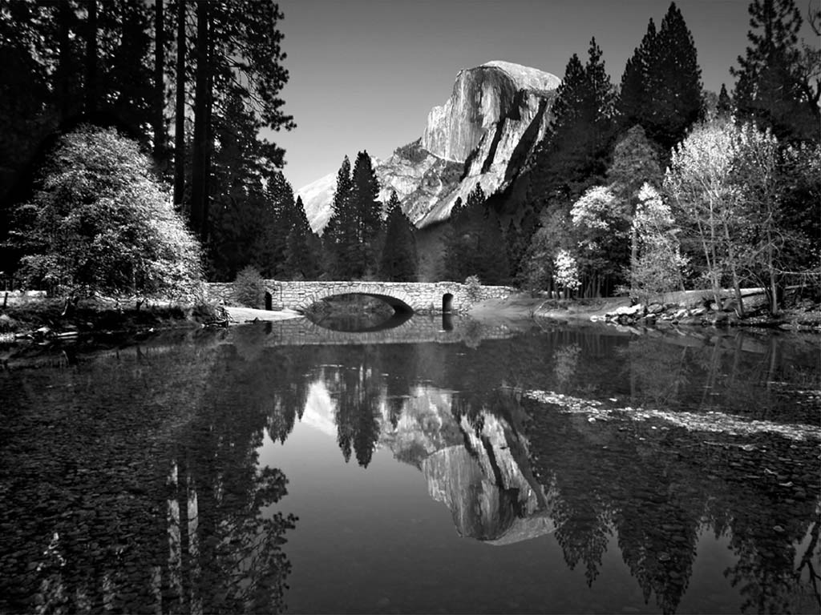
Figure 1.1: Caption created with “insert, reference, caption, figure” and the style changed to “thesis-figure caption
Figure 2.1: paste special, as enhanced metafile

- Equations Style
All equations should be centrally aligned with proper numbering. Use Microsoft Word Equation Editor. E.g.,
(3.1)

Begin typing or pasting the rest of your chapter 1 text here (and then deleting above text)

Chapter 3

METHODOLOGY

First order Heading 1
This is first order heading 1, the body text should be 12 regular and indent should be 0.5 of first line of paragraph left margin should be 1.5 and space between two lines should be double , space after and before line should be 6pt

First order Heading 2
This is first order heading 1, the body text should be 12 regular and indent should be 0.5 of first line of paragraph left margin should be 1.5 and space between two lines should be double , space after and before line should be 6pt

First order Heading 3
This is first order heading 1, the body text should be 12 regular and indent should be 0.5 of first line of paragraph left margin should be 1.5 and space between two lines should be double , space after and before line should be 6pt

Second order heading 1
This is second order heading 1, the body text should be 12 regular and indent should be 0.5 of first line of paragraph, left margin should be 1.5 and space between two lines should be double , space after and before line should be 6pt

Second order heading 2
This is first order heading 1, the body text should be 12 regular and indent should be 0.5 of first line of paragraph left margin should be 1.5 and space between two lines should be double , space after and before line should be 6pt
These paragraphs are in “thesis-body text.” Other styles including captions, headers etc. can be used as presented in the previous chapter. Table 2 summarizes all of the styles that can be used with this template.
Table 2.1: Styles used in this template

Style name | When used
Heading 1 | Chapter titles
Heading 2 | Primary headers
Heading 3 | Sub headers
Heading4 | Sub-sub headers
Thesis-body text | All paragraphs
Thesis-bullets | Bullets
Thesis Figure caption | All figure captions.
Thesis table caption | All table captions
Thesis-eqn | equations
Thesis-reference | Reference list at end of thesis

Chapter 4

RESULTS

First order Heading 1

This is first order heading 1, the body text should be 12 regular and indent should be 0.5 of first line of paragraph left margin should be 1.5 and space between two lines should be double , space after and before line should be 6pt

First order Heading 2

This is first order heading 2, the body text should be 12 regular and indent should be 0.5 of first line of paragraph left margin should be 1.5 and space between two lines should be double , space after and before line should be 6pt

Second order Heading 1

Second order Heading 1

Results, findings, of researchOR manuscripts
This template is best used for directly typing in your content.

Chapter 5

DISCUSSION
It is best to also reiterate information in your literature review to help substantiate the findings of your research. In general, there should be no new information presented here. It should be a synthesis of information that you’ve already discussed.
This template is best used for directly typing in your content.

CONCLUSIONS
Policy and research implications of your research results, and future research aspects. This template is best used for directly typing in your content.

REFERENCES
Includes all references: articles, media facts, books, reports, regulations, internet articles, papers that you referenced from the text. Use the APA style of referencing (www.apastyle.org).
Or any other standard format as per requirement of the subject.

APPENDICES
Type or paste your appendices here. Appendices are a place to organize and include all of the “extra” material that is important to your research work but that is too detailed for the main text. Examples can include: specific analytical methods, computer code, spreadsheets of data, details of statistical analyses, etc. But, these materials do not speak for themselves. There should be a reference to these materials from the main chapters and there should be some text at the beginning of each appendix to briefly explain what the information is and means that is included in that appendix.

Appendix A
.

Appendix B

